**TASK ON RDS:**

**1.Create MariaDB DB on EC2:**

Navigate to ec2 and launch a instance with all default configurations.

we shall connect using aws cli

We shall update the packages.

Its time to install Maria DB package on the cli.

Command to install Maria DB- yum -y install mariadb105-server.

105 is version 10.5 of Maria db and Amazon Linux provides support to that version as of now.

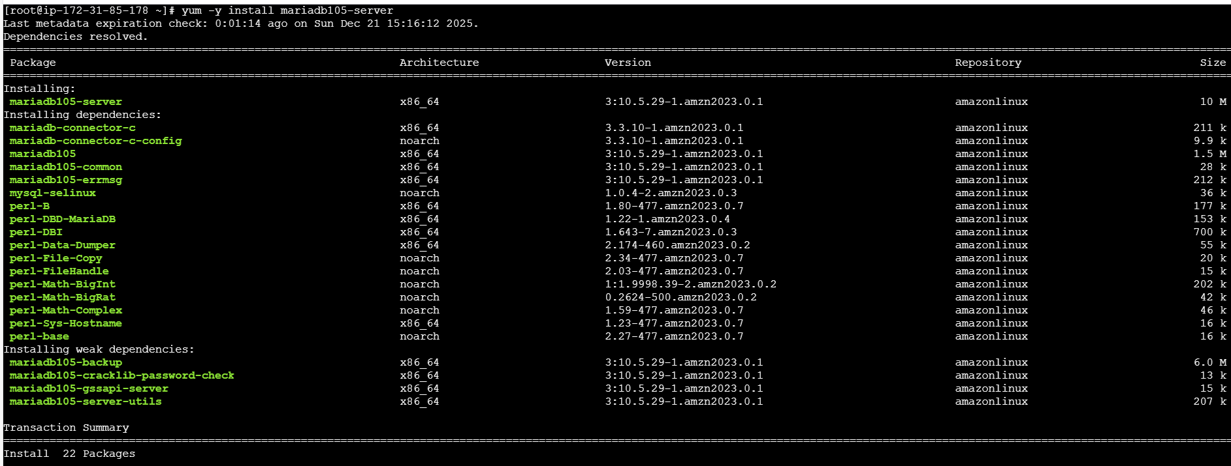

Package is installed successfully.

Successfully, the package is installed. Now, lets create some credentials including DB name, DB password, DB Root password and DB user.

Credentials updated

Once credentials updated in cli for Maria db, we need to provide access and privileges to user.

**There are few commands that needs to be run including:**

**Creating Database-** echo "CREATE DATABASE ${DBName};" >> /tmp/db.setup

**Creating user-** echo "CREATE USER '${DBUser}' IDENTIFIED BY '${DBPassword}';" >> /tmp/db.setup

**Grant all Privileges-** echo "GRANT ALL PRIVILEGES ON *.* TO '${DBUser}'@'%';" >> /tmp/db.setup

**Flush Privileges-** echo "FLUSH PRIVILEGES;" >> /tmp/db.setup

Once provided, change Directory to /tmp and list all the files.

We can verify the privileges by using command- cat db.setup

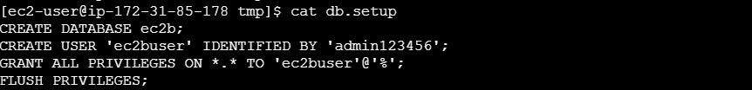

**Finally, we shall start and enable the service**

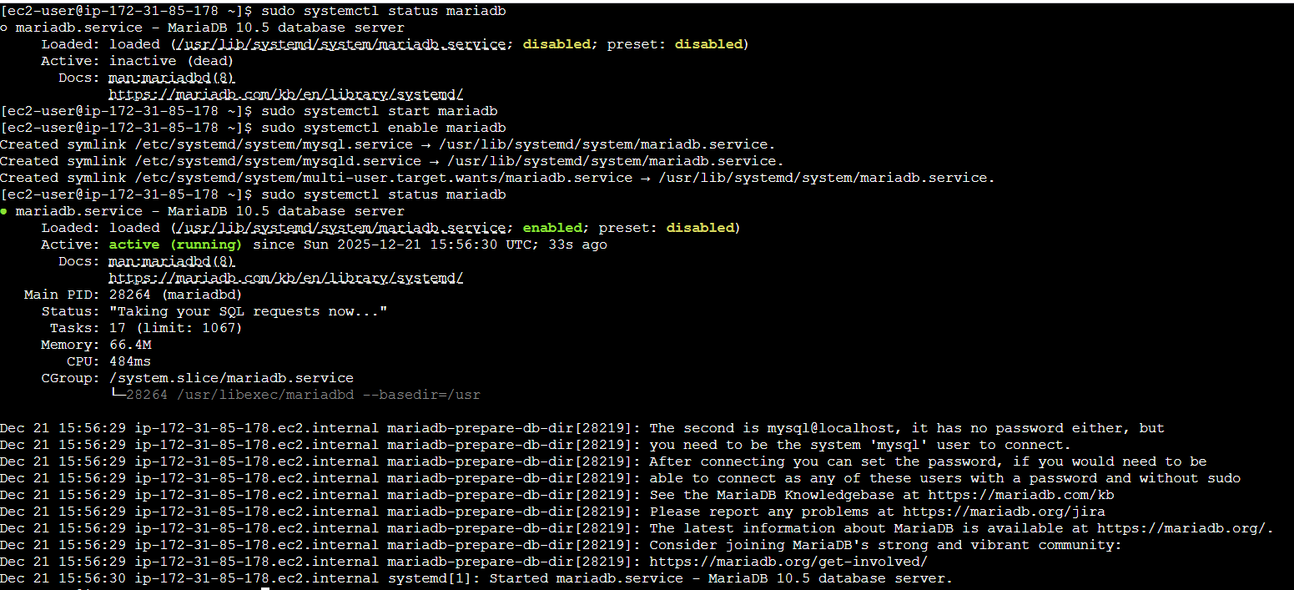

Let’s secure the installation using command- **sudo mysql_secure_installation**

**2.Insert some dummy data:**

Using command- mysql -u root -p login to maria db.

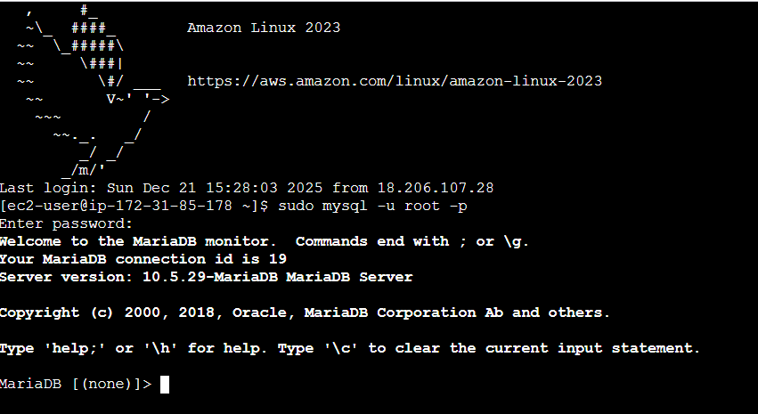

Now, let’s check if we have existing Databases- SHOW DATABASES;

After verifying, create- CREATE DATABASE <SCHOOL>;

Once again verify the Databases- SHOW DATABASES;

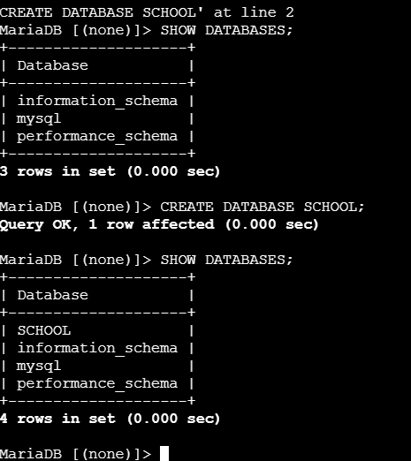

Now, we changed our Database to School using command- USE SCHOOL;

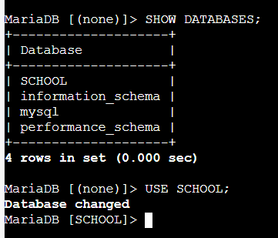

Let’s create a table under our Database School- CREATE TABLE <Students> (id INT, name VARCHAR(45));

Using command to verify if the Table is created- **SHOW TABLES**

Once Table created as Students, now, we need to add the Students to the list. Used command**- INSERT INTO <STUDENTS> (id, name)**

Then use command**- SELECT * FROM <Students>** to list the added Students in the list.

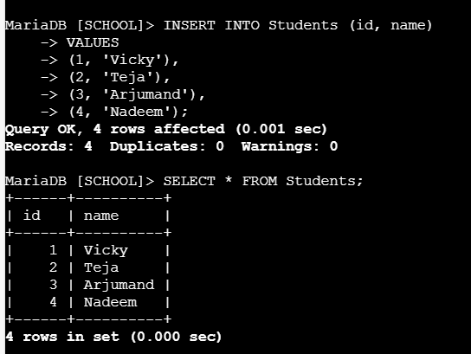

**3.Take the backup of dummy data on EC2:**

First, we need to exit from the previous work using command**- ctrl+z**

Login back using command**- sudo mysql -u root -p**

Change the directory to root.

Now, let’s take the backup of our Database created earlier using command- **mysqldump -u root -p <SCHOOL> >SCHOOLbackup.sql**

Now, lets verify if the backup is successful.Use command- **cat SCHOOLbackup.sql**

**4.Launch MariaDB RDS instance:**

Navigate to Aurora and RDS and create a new database for our requirement.

Select MariaDB from the list.

Select the Engine Size and choose a sample template.

Here, we selected free tier for development purposes.

Master username is admin

I have selected self-managed, instead of aws managed for credentials.

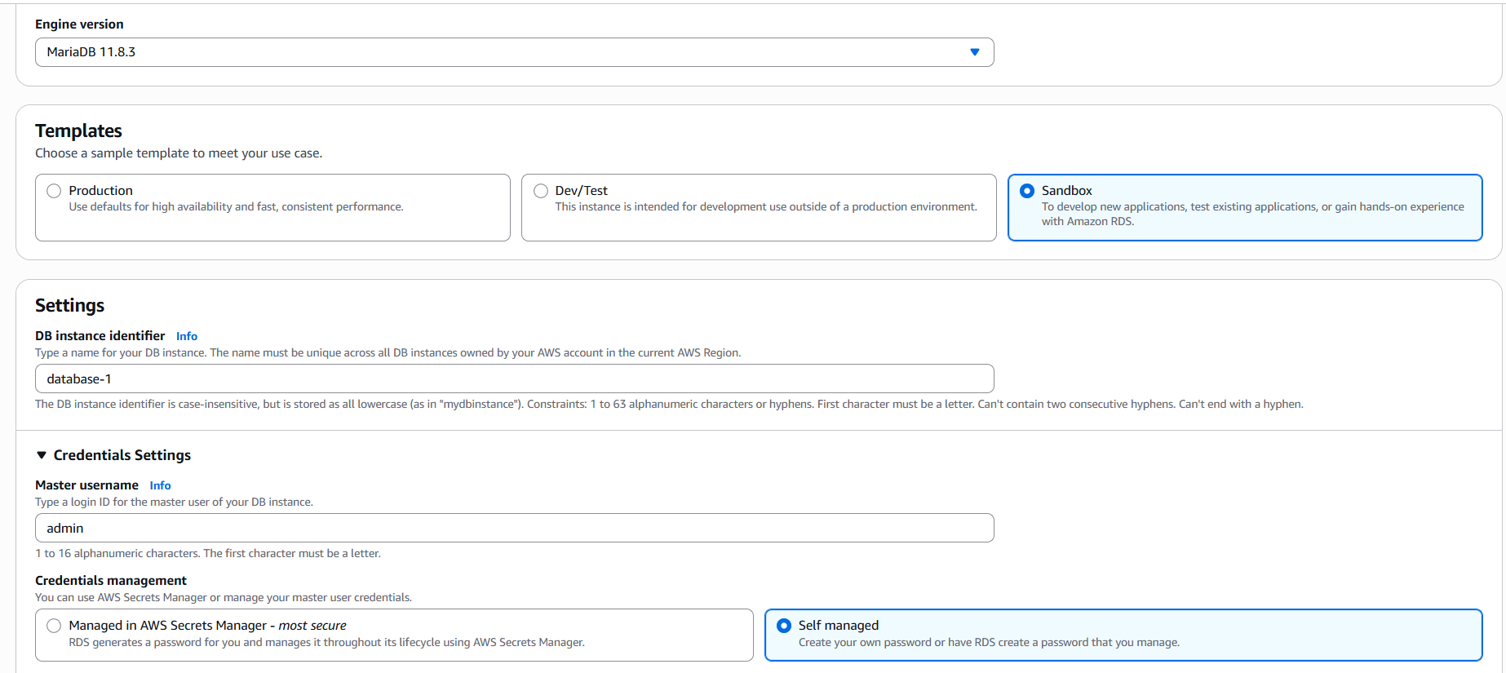

Master password is set.

Select the configuration- here as per the free trail- Burstable class is available.

Storage is allocated.

Connectivity is updated to connect to ec2 and updated default VPC.

Here, we are not selecting any monitoring services.

Its taking sometime to create a RDS.

In meanwhile, the DB is getting created, aws is asking us to save the credentials.

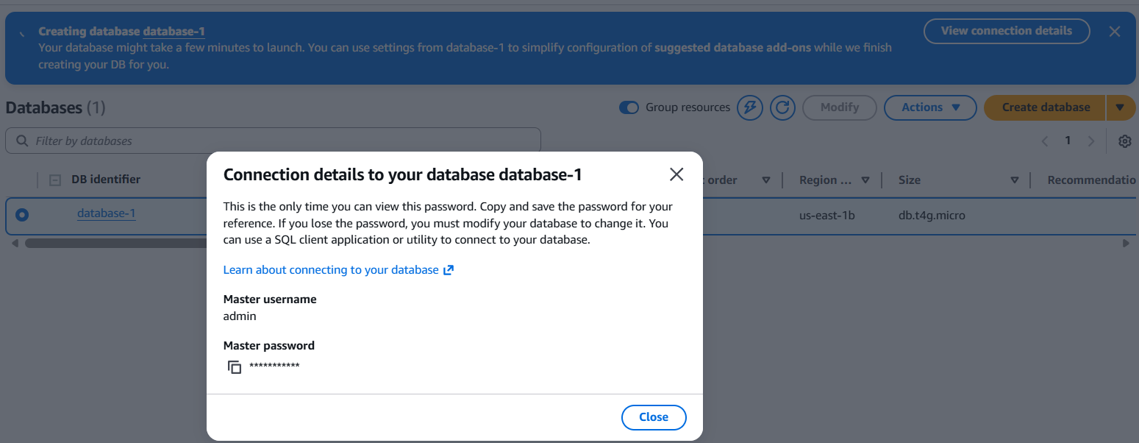

Edit the security rules in ec2 instance to allow **MySQL- 3306.**

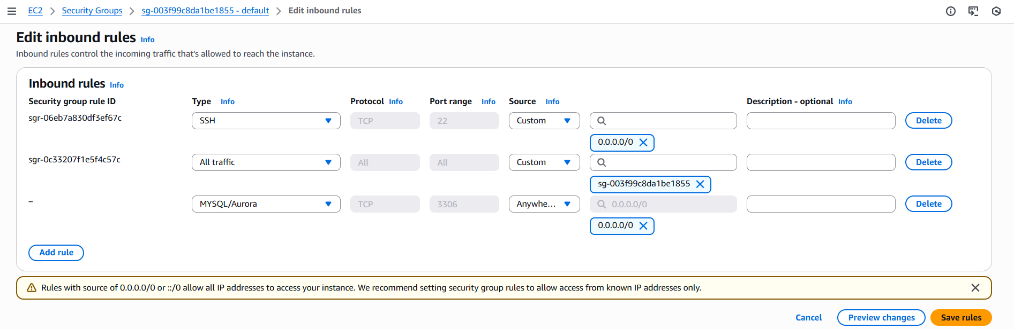

**Successfully, we created a Maria DB RDS in aws.**

**5.Migrate database from EC2 to RDS:**

Navigate to ec2 and click on actions 🡪 Networking 🡪 Connect to RDS Database.

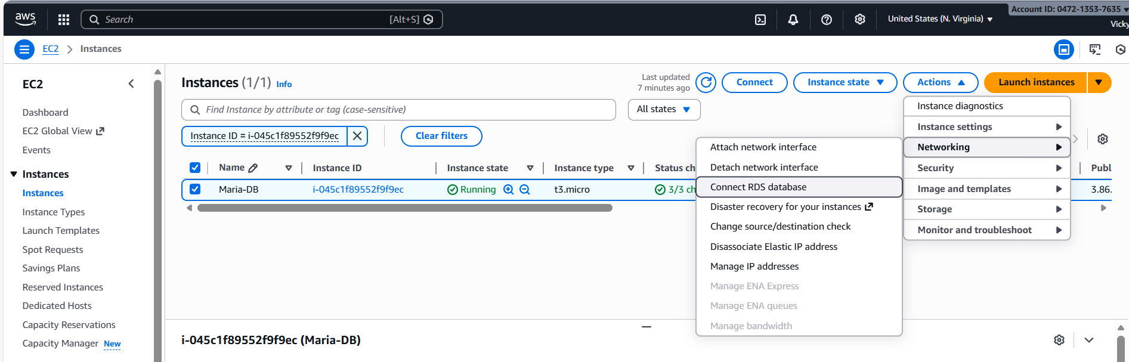

Connect to Instance and continue

Now we have connected to RDS database.

Logged into MariaDB via ec2

Listed Databases

Created a new Database and verified

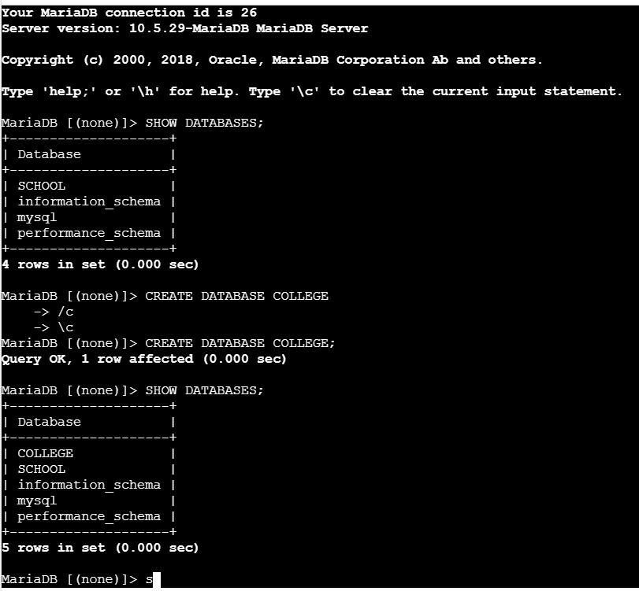

Let’s create a table below

Checked into College DB.

Created Table <techie>

Added values

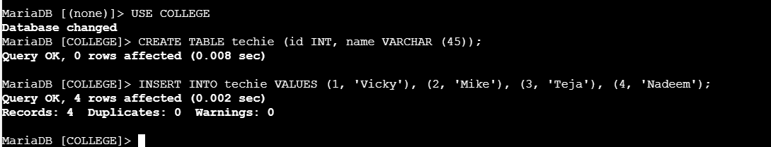

Listed the table created.

Using command- mysqldump -u root -p <COLLEGE> >COLLEGEbackup.sql, we did backup the data**.**

Using command- **ls -lh**, we verified the backup is successful.

Using command- **cat COLLEGEbackup.sql**, we verified the tables backup is successful.

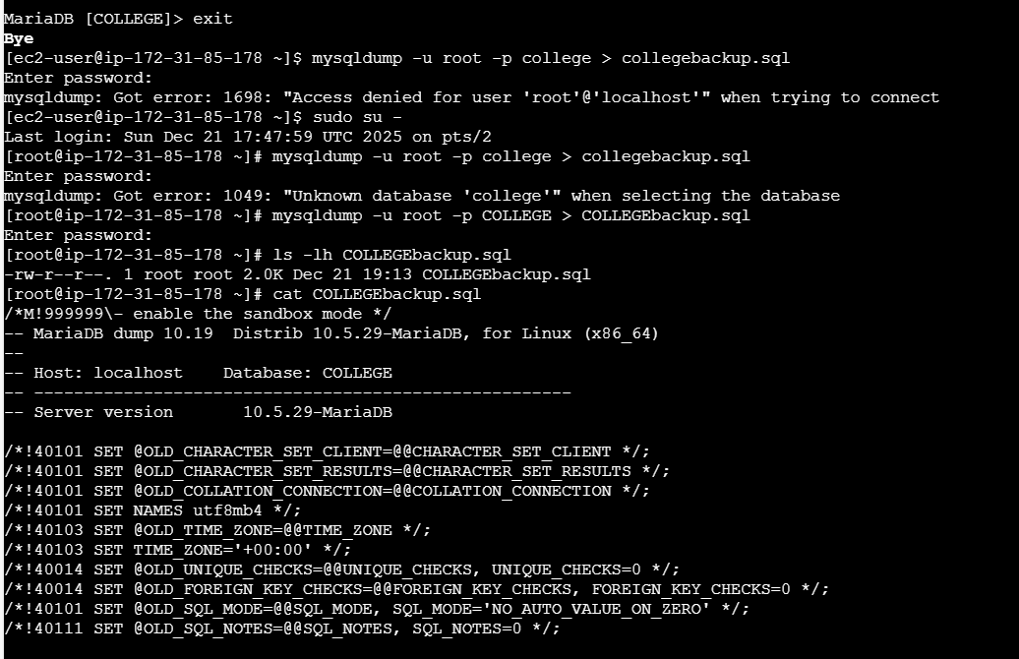

exit from the server and login back using the endpoint- **mysql -h <endpoint> -u admin -p -ssl**

Now let’s create same Databases as we have in maria db.

Created COLLEGE and SCHOOL, which we have in maria db.

Missed out a step in previous step, we need to change our Database to COLLEGE, which we created in RDS DB.

Now, we need to backup from ec2 to RDS. Used command- mysql -h <endpoint> -u admin -p <rds db_name> <Master_Username from RDS> -p COLLEGE < backup.sql

Now, backup is complete. Used command- ls -lh <DB_NAME>backup.sql

**6.Install MySQL DB on EC2:**

Launched a new instance named- MySQL DB

Navigate to website and get a installation URL.

Installed My SQL DB package

Installed MySQL Repository package as well.

Let’s install maria db package

Started, enabled the service.

Installed mysql using command- sudo mysql_secure_installation

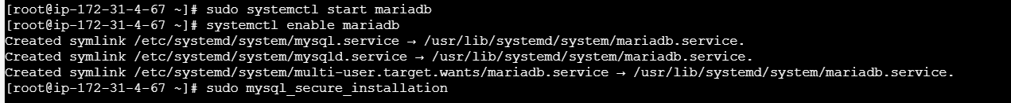

Finally, we can login to our mysql using mysql -u root -p

**7.Launch MySQL RDS image:**

Navigate to Aurora and RDS- Create a Database (MySQL)

Select Engine Version and Choose Template

Name provided for DB.

Master Username and Password is managed by user, not aws.

Choose the Instance config.

Storage is updated and allocated until 20 GB.

For connectivity, We are allowing ec2 instance connect and attached ec2 instance which we used earlier to install maria db and Mysql.

VPC selected and chose AWS managed.

Finally Mysql DB created and available for use.

**8.Configure Multi-AZ:**

Navigate to created DB and click 🡪Actions 🡪Convert to Multi-Az deployment.

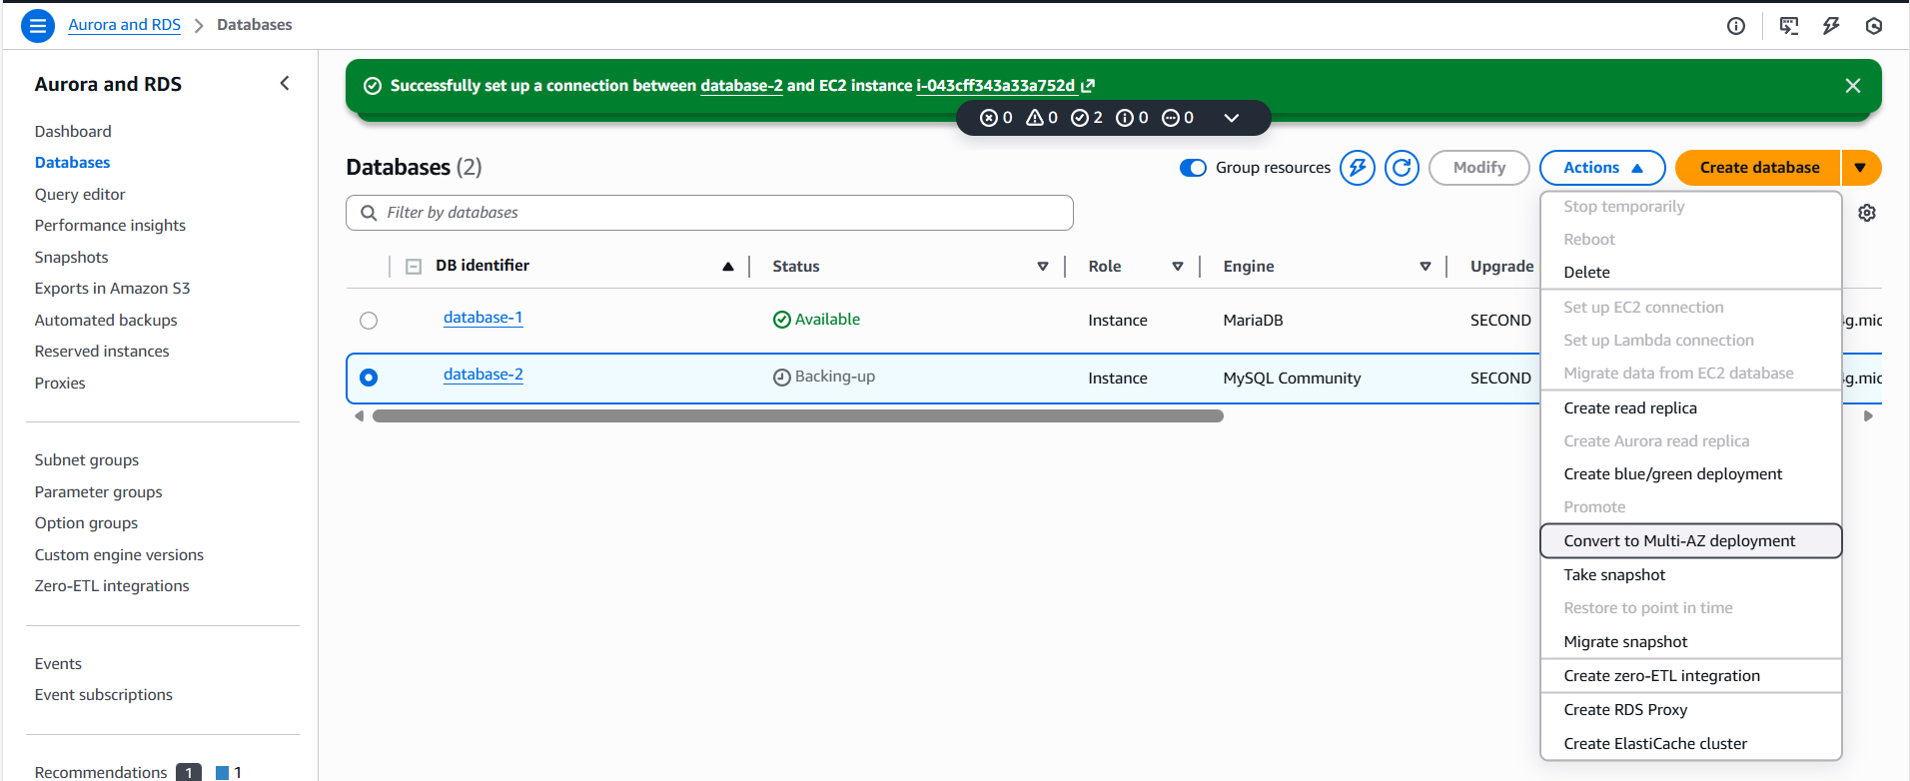

Apply Immediately and verify on the main browser, if created.

Multi-AZ created successfully. We will not be able to access the standby as per default.

Now, we can see the Multi-AZ is greyed out, so it is successfully created.

**9.Take backup of DB and restore the DB:**

Navigate to RDS and Aurora and take a snapshot of the existing Database available.

enter the identifier and take snapshot.

**Step** Created Snapshot successfully.

We are removing the DB from main page and restore from Snapshot.

Navigate to Database and verify, the record is deleted.

Navigate to Snapshots and click 🡪 Actions and select Restore snapshot, so it will get recovered and DB will be on main page.

Now, we can see the database-1 is getting restored.

**10.Create read replica:**

Navigate to Database instance and select the DB, we want to perform Read replica.

I have already created Read-replica for this DB. So, we cannot duplicate.

